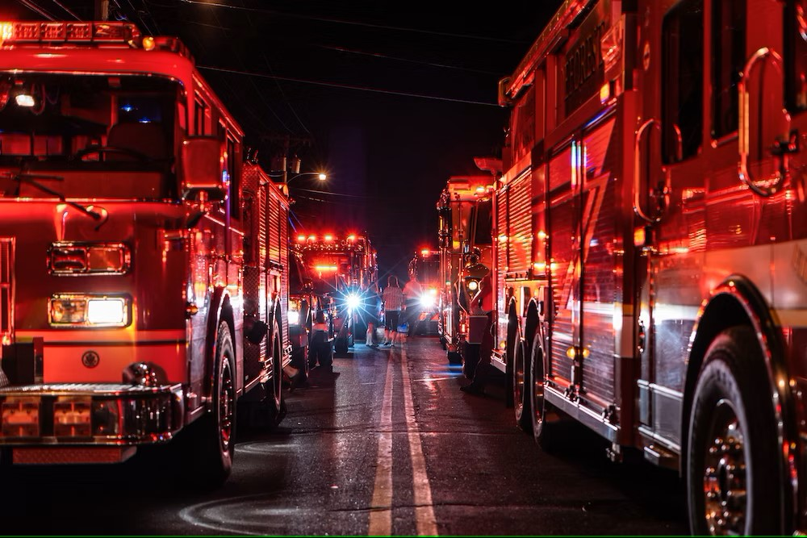

|  |
| --- |
| MONTHLY REPORT  2025 |
|  |
| FEBRUARY ISLE OF PALMS FIRE & RESCUE  Authored by: Craig K. Oliverius, Fire Chief |



# OPERATIONS

|  |
| --- |
| Incident by Type |

## Residency Status

TOTAL INCIDENTS FOR THE MONTH: 102

Resident Calls: 33

Non-Resident Calls: 57

Unknown: 12

## Emergency Medical Incidents

#### Isle of Palms Fire & Rescue

Number of Emergency Medical Incidents: 22

Number of Resident Emergency Medical Incidents: 12

Number of Non-Resident Emergency Medical Incidents: 7

Number of unknown residency Emergency Medical Incidents: 3

## Average Unit Performance

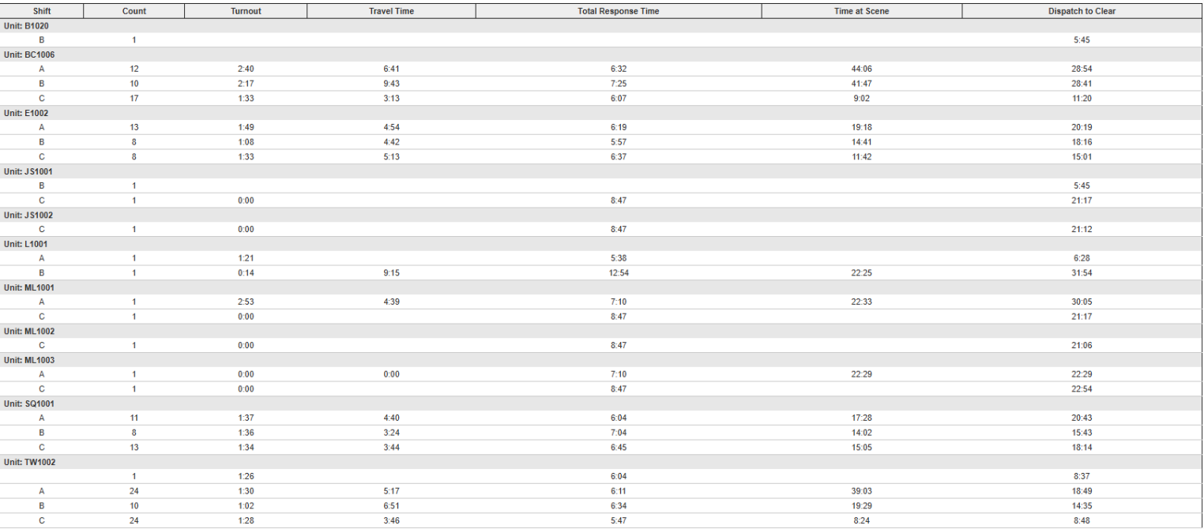

## Heat Map

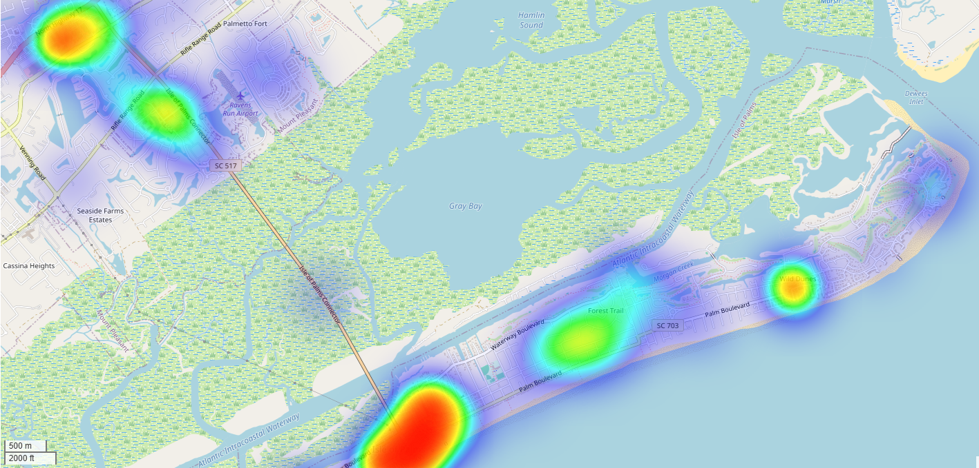

## Incidents by Shift and District

## Response Mode

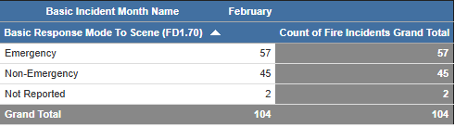

## Auto/Mutual Aid

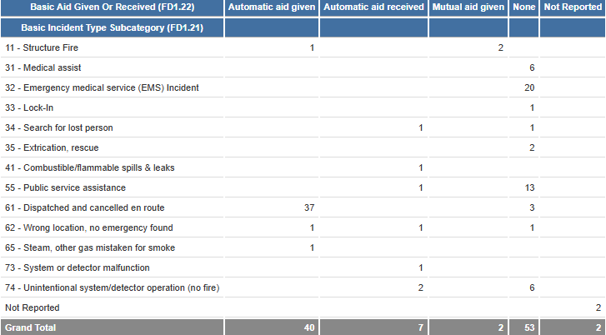

# TRAINING DIVISION

## Monthly Training Schedule

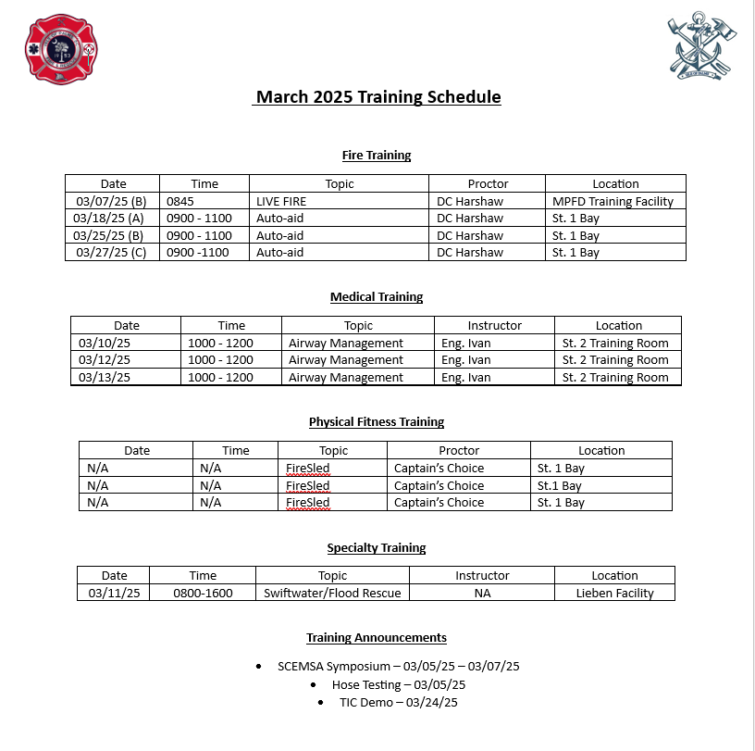

# FIRE MARSHAL

## Fire Marshal’s Report

February

* Target Hazard Training at Windjammer
* Safety Committee Meeting at City Hall
* Live Fire Training at MPFD Training Facility
* Found Resolution to Coconut Joe's/Smuggler's issue
* LRA Meeting
* Lowcountry Regional Fire Marshal's Meeting at Citadel Mall
* Completed Fire Codes and Standards Training
* Completed Multiple Fire Inspections
* Gave tour of Station 1 to new 911 Dispatchers
* Attended Medical In-service training